Correlation Coefficient of all pair-wise

Firstly, we look at the Pearson’s calculation between pairs of relationship.

This table shows the Pearson calculation between the relationships.

|  |  |  |  |  |
| --- | --- | --- | --- | --- |
| Pearson calc. | Employment_Rate | Total Liabilities(TTLIAB) | Total Assets(TTASSET) | SG_GDP |
| Employment_Rate | - | -0.039 | -0.044 | 0.075 |
| Total Liabilities(TTLIAB) | -0.039 | - | 0.842 | 0.0146 |
| Total Assets(TTASSET) | -0.044 | 0.842 | - | -0.0166 |
| SG_GDP | 0.075 | 0.0146 | -0.0166 | - |

As seen above, the strongest Pearson correlation between these relations are between Total Liabilities and Total Assets. This suggests that total assets does rely on total liabilities. This is also supported by the basic accounting equation states that Assets = Liabilities + Stockholders Equity.

Also, as seen above, the Pearson correlation between Employment rate and Total Liabilities is -0.39 which indicates the presence of a weak downhill (negative) linear relationship. The negative sign indicates that when Employment rate increases, its total liabilities of a company value decreases.

Regression

Having to know its correlation, we can carry on with doing regression by investigating further on how the relationship of the variables related to one another. To do this, we can graphically construct scatter plots of all pair-wise combinations of variables in the data frame. This can be done by typing:

Scatterplot:

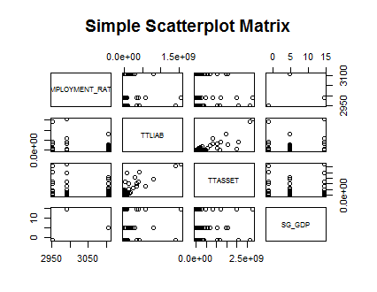

To fit a multiple linear regression model with employment rate as the response variable and Total Liabilities, Total Assets and Singapore’s GDP as the explanatory variables, use the command:



When calling the result:



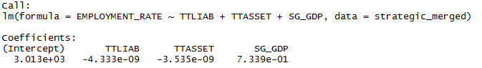

This output indicates that the fitted values is given by

$\hat{y}$ = 3.013e+03 -4.333e-09 $x_{1}$-3.535e-09 $x_{2}$ + 7.339e-01 $x_{3}$

We begin by testing whether the explanatory variables collectively have an effect on the response variable. If we can reject this hypothesis, we continue by testing whether the individual regression coefficients are significant.

We can access the results of each test by typing: 

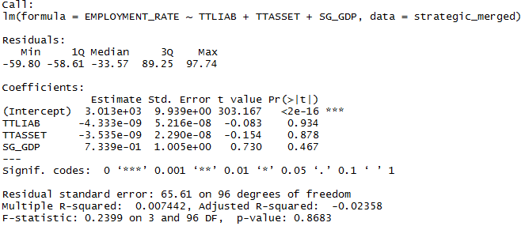

The output shows that F=0.2399 (p=0.8683), indicating that we should fail to reject the null hypothesis that the variables total Liabilities, total Assets and GDP have effect on employment rate. The result also shows that the p-value of the variables is not statistically significant. In other words, we are reasonably sure that our observed data can be explained by chance alone.

References:

<https://mchankins.wordpress.com/2013/04/21/still-not-significant-2/>

<http://blog.minitab.com/blog/adventures-in-statistics/how-to-interpret-regression-analysis-results-p-values-and-coefficients>

<http://statisticalconcepts.blogspot.sg/2010/04/interpretation-of-correlation.html>